**Extended Kalman Filter for a Miniature Strapdown Inertial Measurement Unit Attitude estimation**

Akash Sharma and Saumya Sarawagi

**2D Orientation Estimation**

**1 State Variable**

As the first step, we only estimate the roll angle using the accelerometer sensor along y and z direction which come from d(6) and d(7). The state is one dimensional and is X = $θ_{x}$.

For the Kalman Filter Modelling we get the following equations:

$θ_{k+1}= θ_{k}+w$ where w is assume to be of normal distribution

$y= \begin{matrix}a_{y} \\ a_{z}\end{matrix}= \begin{matrix}-sinθ \\ cosθ\end{matrix}+v$ where the units are g for the accelerometer readings

From, the above equations the Kalman Filter is programmed as follows

F = 1

H = $\begin{matrix}-cosθ \\ -sinθ\end{matrix}$ obtained by differentiating the above equation for the output to linearize

The filter is programmed on Matlab as follows and real and simulated data are used to tune the values of Q and R.

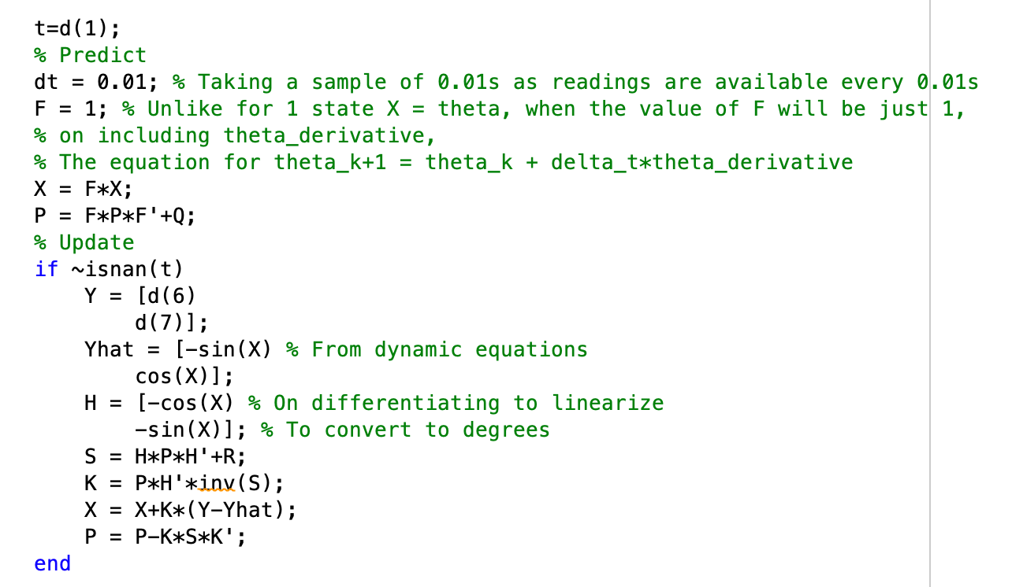

For this case, only the accelerometers are used and R is assigned a high value because the accelerometers do not give accurate readings specially when the spirit level is moved horizontally, which is why the gyroscope will be implemented in the next section. High level of confidence exist in the model and hence, the value assigned to Q is less. On observing the model performance for these tunings, a satisfactory agreement of the filter with the simulated data was observed and the graph in the next page summarizes it.

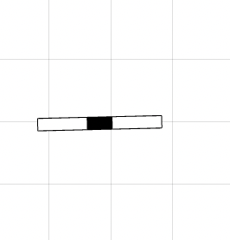

*Figure 1. 2D estimation of roll angle for a single state Figure 2. Animation of the Spirit Level*

**2 State Variable**

As discussed above for better and more accurate sensor results, a gyroscope is needed. For enhancing the model further a two dimensional state vector is defined, $X={\left[\begin{matrix}θ_{x} & \dot{θ_{x}}\end{matrix}\right]}^{T}$.

$$θ_{k+1}= θ_{k}+\dot{θ} Δt$$

$$\dot{θ_{k+1}}= \dot{θ_{k}}$$

$y= \begin{matrix}a_{y} \\ a_{z} \\ \dot{θ}\end{matrix}= \begin{matrix}-sinθ \\ cosθ \\ \dot{θ}\end{matrix}$

For the above set of equations:

$$F= \left[\begin{matrix}1 & Δt \\ 0 & 1\end{matrix}\right]$$

$$H= \begin{matrix}-cosθ & 0 \\ -sinθ & 0 \\ 0 & 180/π\end{matrix}$$

For this system the component of R matrix corresponding to the gyroscope is assigned a lower value to insinuate more confidence on its readings when compared to the accelerometer.

*Figure 3. 2D estimation of roll angle for two state variables*

**Validation with Real System**

The same code was used with the given IMU (with both 1 state and 2 state) and the results was satisfactory. The produced model was closely following the actual system.

**Discussion**